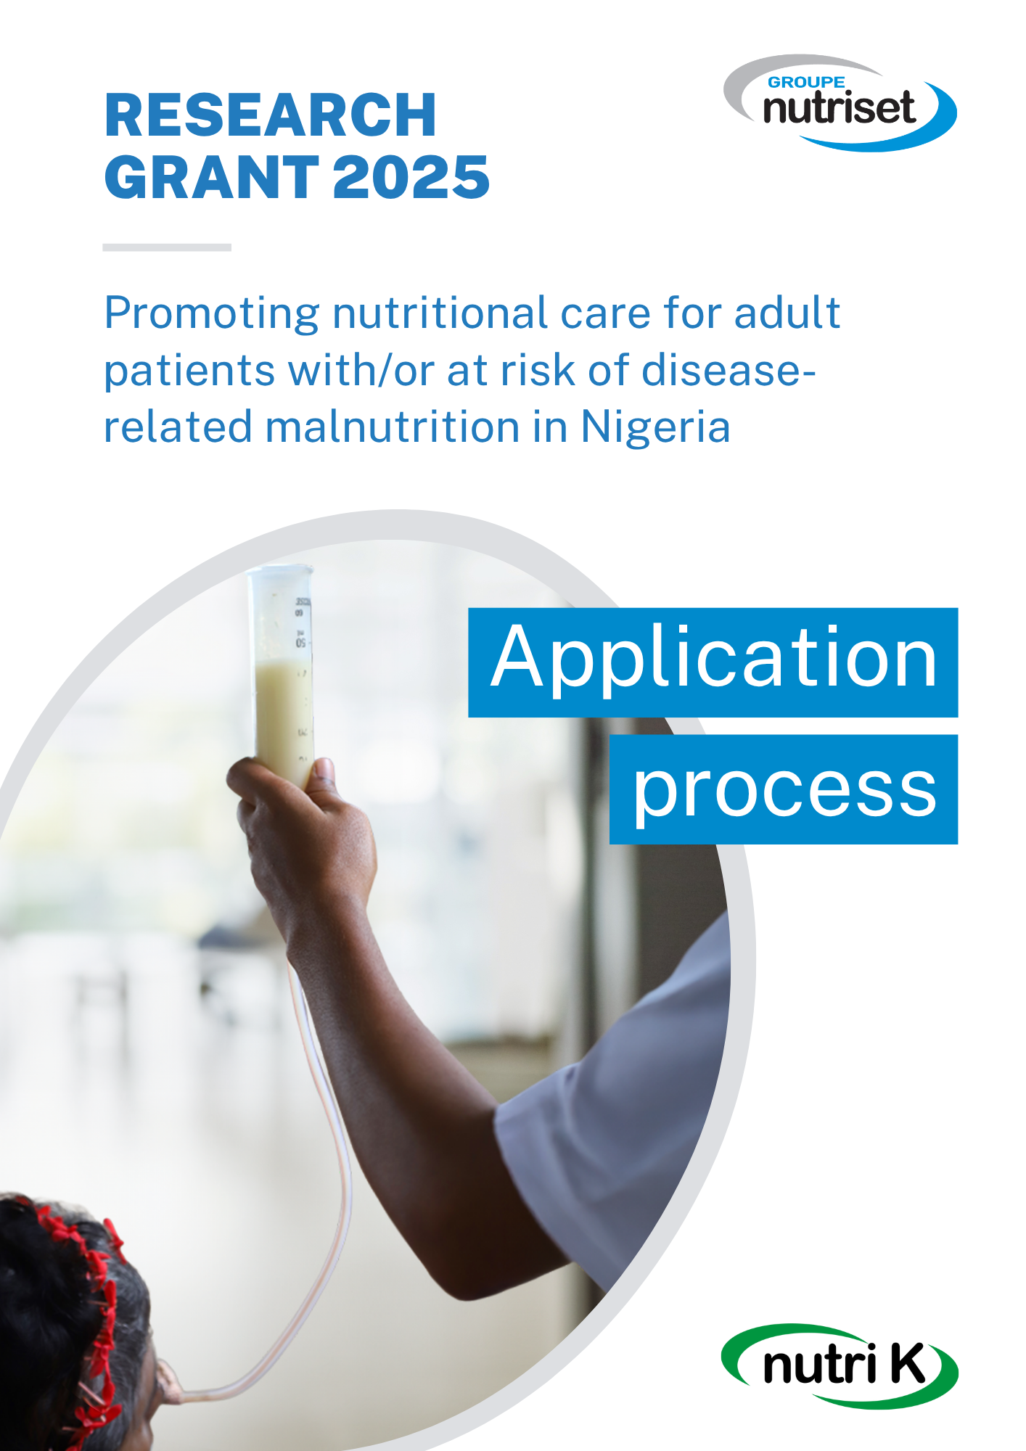f

**Aim of the grant**

The grant will be awarded to a project that contributes to improving the screening, diagnosis and/or the management of disease-related malnutrition in adults, in hospital settings and in Nigeria. (Projects regarding the management of acute malnutrition or stunting are not eligible).

The Nutriset Group grant helps to fund a research project related to disease-related malnutrition in adults. This may include:

* clinical research projects,
* public health research projects,
* evaluations of professional practices,
* action-research (including dissemination of information or training).

**Amount and payment of the grant**

The amount of the prize for 2025 will be €10,000.

Payment of the Research grant will be made to any public or private establishment or professional medical or nutrition association to which the project applicant claims to belong. The organization must be represented in the country concerned by the project.

**Eligibility**

The project leader must be a doctor, pharmacist, researcher, science, PhD student (in a field related to the aim of the prize), medical or pharmacy intern, dietician/nutritionist, nurse or hospital engineer.

The prize will finance a project carried out in Nigeria.

**Submission of projects**

Applications for the grant must include:

* the completed and firmed application form,
* the CV of the project leader,
* a letter from the project's scientific leader or principal investigator agreeing to take part in the grant and supporting the initiative,
* a letter from the head of department or laboratory director (if different from the scientific director) agreeing to participate in the grant.

Applicants are fully responsible for the content of their application, including any material generated with the assistance of AI tools. Any use of AI must be clearly disclosed (eg. “During the preparation of this application, the author used [NAME OF TOOL] to [PURPOSE]. The content was subsequently reviewed and edited, and the author take full responsibility for it”). Participants are expected to adhere to principles of responsible, lawful and ethical AI use.

The application must be written in English (other languages are not accepted).

Any application that does not comply with the above instructions will not be examined.

Applications must be sent by e-mail to: [grant@nutriset-dev.fr](mailto:grant@nutriset-dev.fr)

Applications are open until **30 September 2025 (23:59 CET)**.

**Selection**

Applications will be assessed on:

* the merit of the project
* the scientific quality of the project leader and team
* the scientific quality of the project
* the feasibility of the project.

The project must be original, feasible for the applicant and must be completed within the 15 months of receiving the prize i.e. before December 2026. The project must receive the favorable opinion of an institutional ethics committee before it is launched.

The jury will be made up of Dr. Fanny Morel, Nutrition Scientist at Nutriset Development and two to three external reviewers. The jury will rank the projects selected. It will be sovereign in all matters relating to this grant and will rule without obligation to report on its discussions.

**Commitments of the winner**

The work carried out will be the subject of a report at the end of the 15 months following the award of the grant and must be presented by the grant holder at a local congress dedicated to nutrition and ideally at the national or regional society of clinical nutrition in his/her country. Nutriset may allocate a contribution to this aim.

The winner shall submit a manuscript with the results of the project to an international scientific journal within 18 months of the award of the prize.

The grant holder should acknowledge Nutriset Group's financial support at any event and in any subsequent publication in which the prize-winning work is reported.