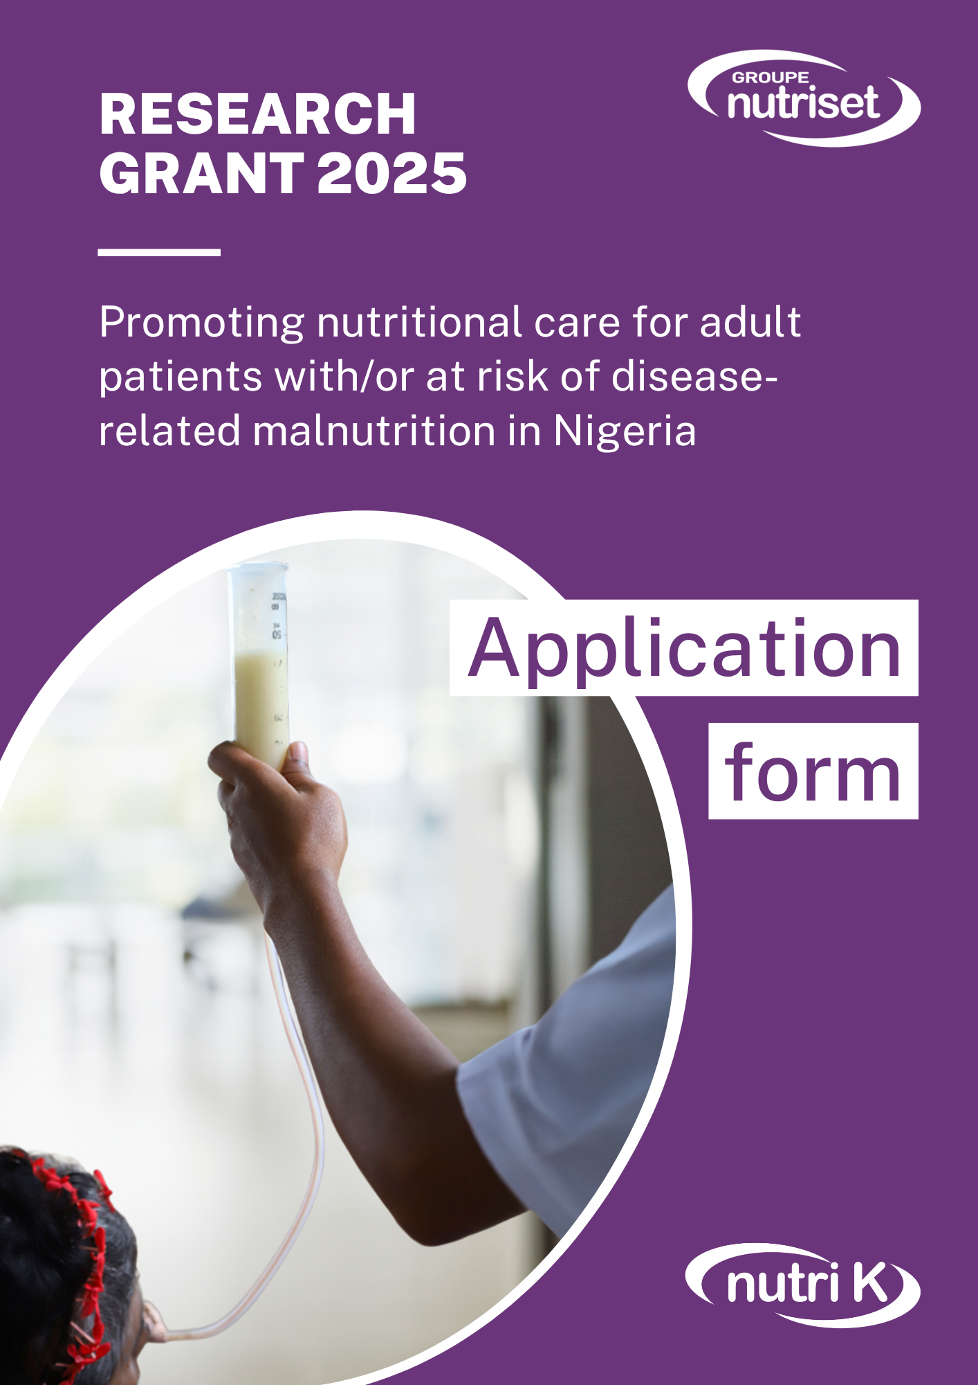

Candidate

Name:
Surname:
Phone number:
E-mail:
Address:

Please attach a CV to your application, giving details of your academic background, professional experience, and a list of publications (maximum 2 pages).

Organisation

Organisation name:
Organisation address:

Organisation director:
Scientific director:
Phone number:
E-mail:

Project title

Project summary

Write a summary of the project in one page maximum (Calibri 11 font, single-spaced) detailing the following points: Introduction, Objectives, Methods and Expected results.

Project description

Write a 5-page maximum description of the project (single-spaced Calibri 11 font) detailing the following points: State of the question, Hypotheses, Objectives, Materials & Methods, Results, Discussion and References.

Detailed budget and project financing

Specify the total cost of the project, detailing expenditure on equipment, materials and personnel. Specify other sources of funding (amount and origin).
Planning

Present a brief timetable over 12 months, specifying the various stages of the project.

I have read and accept the grant regulations.
On:
Signature of applicant
Done at:

Submit your application

To ensure that your application is complete, please include the following information:

- This application form, completed and signed
- CV of the project leader (2 pages maximum)
- A letter from the project's Scientific Director agreeing to take part in the prize and supporting the initiative
- A letter from the head of the host structure

As a reminder, the application must be written in English (other languages are not accepted).

The complete application should be identified as "Your name_GrantNutrisetDev2025" and should be sent by e-mail to the following address: grant@nutriset-dev.fr, specifying the subject: Application NutrisetDev 2025 Grant.

Deadline for submission: 30 September 2025 (23:59 CET)

MODEL LETTER
(to be completed by the Scientific Director or Principal Investigator of the project)

I, the undersigned, (first name, surname, position) .....................................................................,
confirm my agreement to the application of (name of the applicant)..........................................
and undertake to support the implementation of the following project (project title)................
..........................................................................................................................................................
........................................................................................................................................................ .

Date: ....................................

Signature

MODEL LETTER
(to be completed by the Director of the applicant's host establishment)

I, the undersigned, (first name, surname).....................................................................................,
Director of (name and address of establishment) .........................................................................
..........................................................................................................................................................
..........................................................................................................................................................
..........................................................................................................................................................
confirm my agreement to the application of (name of the applicant)..........................................
and undertakes to support the implementation of the following project (project title)..............
..........................................................................................................................................................
........................................................................................................................................................ .

Date: ....................................

Signature

